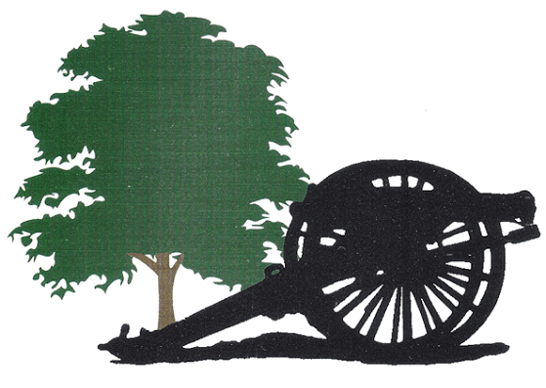
Locust Hill
Lounge and Light Fare Menu
Turn Baby Turn
Hot Dog $3

Bar Menu
Wings (6)$8.47 (12)$13.24
BBQ, Hot, Mild, Old Bay, Honey Old Bay, Lil Sweet Chili, Teriyaki
Fresh Cut Fries Small $1.99 Large $3.50
Crab Dip $13.00
Served with toasted rustic bread
Chicken Tenders (4) $5.00
Pizza (Personal Size) $10.55
Cheese, Pepperoni

Winter Special Nights
Tuesday
Burger Night
All Burgers served with Chips and coleslaw
Hamburger…$5.95 Cheeseburger…$7.95
Specialty Burger…Priced Daily
Wednesday
Seafood Night
MD Style Crab Cake…$14.95
Shrimp…1 lb $17.00…1/2 lb $9.95
Thursday
Wing Night
$.75 wings
Cary out Special
18 wings – 6 pack Domestic Beer…$25.00
Friday
Chef Tom’s Specials
Items and price vary call for specials
Saturday
Steak Night
Farm to table steak cuts vary weekly Baked Potato and Sides
$21.95

The West Virginia Grills
All sandwiches are served with Chips, Coleslaw, and a Pickle Spear
Philly Cheesesteak panini $5.00
Philly steak smothered with fresh mushroom, onion, peppers, and Provolone cheese
Rueben panini $5.00
Choice of Corned Beef or Turkey with Sauerkraut, house made Thousand Island Dressing, served on Rye Bread with Swiss Cheese
Hot Ham or turkey & Cheese $5.00
Perdue Sliced Ham or Oven Roasted Turkey served on Rye Bread you’re your choice of Swiss Cheese, American, or Provolone
Turkey Pesto Panini $5.50
Oven Roasted Turkey Breast served on Rye Bread with Pesto Aioli and Provolone Cheese
Grilled cheese…………………………………………………………………………….……………. $4.00
American, Swiss, and Provolone Cheese served on Rye Bread. Load it up with bacon and tomato for $2
Beverages

Bottled water……………..$2.50
Bottled Soda………………..$2.50
fountain soda…………...….$1.50
gatorade…………………….…$2.50
Domestic beer……....……...$3.00
Draft beer…………......…..$3.00-4.50
bottle/can……….………...$3.00-4.50
specialty drink….….$4.00-12.50
Like us on Facebook
www.facebook.com/locusthillgolf Follow us on Twitter
@ locusthillgolf
Check out our website: www.locusthillgolf.com to see upcoming events, weather delays, a virtual tour of the course, and much more.

